M.Abdullah.Mahmood
BCS-3B
22f-3289
DS – LAB 7
To: Sir saqib
______________________________________________

Task 2 :
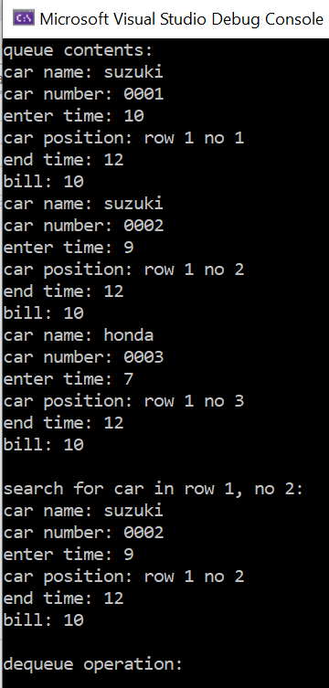
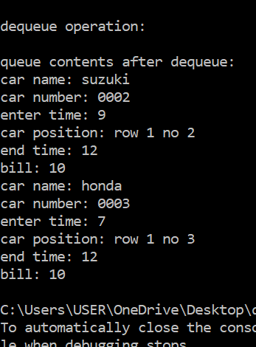
#include <iostream>
#include <string>
using namespace std;

class node {
public:
node* next;
string carname;
string carnum;
int stime;
int etime;
int row, number;
int bill;
string vtype;

node() {
stime = etime = bill = row = number = 0;
carname = carnum = vtype = "";
next = nullptr;
}

node(string carn, int t, int et, int r, int n, string cn, string vt) {
carname = carn;
stime = t;
etime = et;
row = r;
number = n;
next = nullptr;
carnum = cn;
vtype = vt;
if (((etime - stime) / 2 >= 0) && vt == "c") {
bill = ((etime - stime) / 2) * 10;
}
else if (((etime - stime) / 2 >= 0) && vt == "b") {
bill = ((etime - stime) / 2) * 5;
}
else if (((etime - stime) / 2 >= 0) && vt == "hv") {
bill = ((etime - stime) / 2) * 15;
}
else
bill = 0;
}
};

class queue {
public:
node* head, * tail;

queue() : head(nullptr), tail(nullptr) {}

void enqueue(string carn, int t, int et, int r, int n, string cn, string vt) {
node* newnode = new node(carn, t, et, r, n, cn, vt);

if (head == nullptr) {
head = newnode;
tail = newnode;
}
else {
tail->next = newnode;
tail = newnode;
}
}

void dequeue() {
if (head == nullptr) {
cout << "queue is empty\n";
return;
}
node* temp = head;
head = head->next;
delete temp;
}

void display(node* t) {
cout << "car name: " << t->carname << endl;
cout << "car number: " << t->carnum << endl;
cout << "enter time: " << t->stime << endl;
cout << "car position: row " << t->row << " no " << t->number << endl;
cout << "end time: " << t->etime << endl;
cout << "bill: " << t->bill << endl;
}

void displayq() {
node* temp = head;
while (temp != nullptr) {
display(temp);
temp = temp->next;
}
}

void searchqueue(int r, int n) {
if (head == nullptr) {
cout << "queue is empty\n";
return;
}
node* temp = head;
bool found = false;
while (temp != nullptr) {
if ((temp->row == r) && (temp->number == n)) {
display(temp);
found = true;
}
temp = temp->next;
}
if (!found) {
cout << "car not found in the queue\n";
}
}

~queue() {
while (head != nullptr) {
node* temp = head;
head = head->next;
delete temp;
}
}
};

int main() {
queue q1;
q1.enqueue("suzuki", 10, 12, 1, 1, "0001", "c");
q1.enqueue("suzuki", 9, 12, 1, 2, "0002", "c");
q1.enqueue("honda", 7, 12, 1, 3, "0003", "b");

cout << "queue contents:" << endl;
q1.displayq();

cout << endl << "search for car in row 1, no 2:" << endl;
q1.searchqueue(1, 2);

cout << endl << "dequeue operation:" << endl;
q1.dequeue();

cout << endl << "queue contents after dequeue:" << endl;
q1.displayq();

return 0;
}

Task 4 (B)

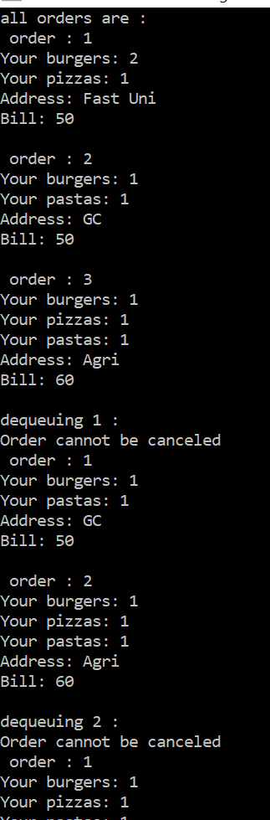
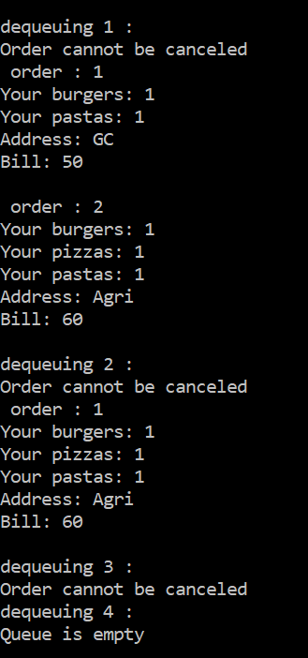
#include <iostream>
#include <string>
using namespace std;
int maxOrders = 0;
class Node {
public:
Node* next;
int pizzaPrice = 10;
int burgerPrice = 20;
int pastaPrice = 30;

int pizza;
int burger;
int pasta;

int time = 0;

int bill;

string address;

Node() : next(nullptr) {
++maxOrders;
};
Node(int p, int b, int pa, string ad) {
pizza = p;
burger = b;
pasta = pa;
address = ad;
next = nullptr;
++maxOrders;
bill = (p * 10) + (pa * 30) + (b * 20);
}

~Node() {};

};

class Queue {
public:
Node* head, * tail;

Queue() : head(nullptr), tail(nullptr) {}

void enqueue(int p, int b, int pa, string ad) {

if (maxOrders >= 10) {
cout << "Queue is full\n";
return;
}
Node* newNode = new Node(p, b, pa, ad);

if (head == nullptr) {
head = newNode;
tail = newNode;
}
else {
tail->next = newNode;
tail = newNode;
}

++(tail->time);
}

void dequeue() {
if (head == nullptr) {
cout << "Queue is empty\n";
return;
}

Node* temp = head;

if (head->time == 0) {
cout << "Dequeuing can be done!\n";
}
else
cout << "Order cannot be canceled\n";

head = head->next;
delete temp;
}

void displayOrders() {
int num = 1;
Node* temp = head;
while (temp != NULL) {
cout << " order : " << num++ << endl;
if (temp->burger > 0) {
cout << "Your burgers: " << temp->burger << endl;
}
if (temp->pizza > 0) {
cout << "Your pizzas: " << temp->pizza << endl;
}
if (temp->pasta > 0) {
cout << "Your pastas: " << temp->pasta << endl;
}

cout << "Address: " << temp->address << endl;
cout << "Bill: " << temp->bill << endl;
cout << endl;
temp = temp->next;
}
}

};

int main()
{
Queue q1;
q1.enqueue(1, 2, 0, "Fast Uni");
q1.enqueue(0, 1, 1, "GC");
q1.enqueue(1, 1, 1, "Agri");

cout << "all orders are : \n";
q1.displayOrders();

cout << "dequeuing 1 : \n";
q1.dequeue();

q1.displayOrders();

cout << "dequeuing 2 : \n";
q1.dequeue();

q1.displayOrders();

cout << "dequeuing 3 : \n";
q1.dequeue();

q1.displayOrders();

cout << "dequeuing 4 : \n";

q1.dequeue();
q1.displayOrders();
return 0;
}

